📅 Student Event Management
System
Campus Event Orchestration Platform
Project Report
Project Type: Web Application
Duration: Academic Project
Date: November 2025
Status: ✅ Completed

📑 Table of Contents

- System Overview
- Database Schema
- Core Functionalities
- Technical Stack
- Learning Outcomes & Challenges

1. System Overview

Project Description
The Student Event Management System is a comprehensive web-based platform designed to facilitate the organization, discovery, and management of campus events. The system enables administrators to create and manage events while allowing students to browse, register, and participate in various campus activities including workshops, hackathons, and seminars.

Key Objectives
Centralize event management for campus institutions
Simplify event registration process for students
Provide administrative tools for event organizers
Track attendance and registrations efficiently
Enhance campus community engagement

User Roles
👨‍💼 Admin User: Can create, edit, delete, and manage events; view registration statistics
👨‍🎓 Student User: Can browse events, register for participation, view their registrations, and access event details

2. Database Schema

Database Overview
Database Name: event_management
DBMS: MySQL
Connection Method: PDO (PHP Data Objects)
Tables Structure

📋 Users Table
CREATE TABLE users ( user_id INT PRIMARY KEY AUTO_INCREMENT name VARCHAR(100) NOT NULL email VARCHAR(100) UNIQUE NOT NULL student_id VARCHAR(20) UNIQUE contact VARCHAR(15) password VARCHAR(255) NOT NULL (hashed) role ENUM('admin', 'student') created_at TIMESTAMP DEFAULT CURRENT_TIMESTAMP )

🎯 Events Table
CREATE TABLE events ( event_id INT PRIMARY KEY AUTO_INCREMENT title VARCHAR(200) NOT NULL description TEXT NOT NULL date DATE NOT NULL time TIME NOT NULL venue VARCHAR(200) NOT NULL capacity INT NOT NULL category ENUM('workshop', 'hackathon', 'seminar') organizer VARCHAR(100) NOT NULL created_by INT (FK - users.user_id)
created_at TIMESTAMP DEFAULT CURRENT_TIMESTAMP )

✍ Registrations Table
CREATE TABLE registrations ( reg_id INT PRIMARY KEY AUTO_INCREMENT user_id INT (FK - users.user_id) event_id INT NOT NULL (FK - events.event_id) name VARCHAR(100) NOT NULL student_id VARCHAR(20) NOT NULL email VARCHAR(100) NOT NULL contact VARCHAR(15) NOT NULL registered_at TIMESTAMP DEFAULT CURRENT_TIMESTAMP )

Entity Relationship
1:N Relationship: One user can have many registrations
1:N Relationship: One event can have many registrations
Cascade Delete: When an event is deleted, all related registrations are automatically removed

3. Core Functionalities

🔐 Authentication & Authorization
User registration with email validation
Secure login with password hashing (PASSWORD_DEFAULT)
Session-based authentication
Role-based access control (Admin/Student)
Password recovery mechanism

📅 Event Management (Admin)
Create Events: Form-based event creation with validation
Edit Events: Modify event details (future events only)
Delete Events: Remove events with cascading registrations
View Statistics: Dashboard showing event metrics
Manage Registrations: View and export registration data

🎫 Event Registration (Students)
Browse all available events with filters
View detailed event information
Register for events with automatic validation
Track personal registrations
Cancel registrations if needed
Search and filter by category/date

📊 Dashboard & Reporting
Admin Dashboard: Total events, registrations, students statistics
Student Dashboard: Registered events, upcoming events
Real-time event capacity tracking
Registration statistics and analytics

🎨 User Interface Features
Responsive Bootstrap 5.3 design (Mobile-friendly)
Font Awesome 6.4 icons for enhanced visuals
Intuitive navigation with navbar
Professional footer with quick links
Form validation (Client & Server-side)
Success/Error alert messages

4. Technical Stack
Frontend Technologie  Technology |  | s  Version | Purpose
HTML5 |  | Latest | Semantic markup & structure
CSS3 |  | Latest | Styling & responsive layouts
Bootstrap |  | 5.3.0 | Responsive UI framework
Font Awesome |  | 6.4.0 | Icon library
JavaScript |  | ES6+ | Form validation & interactions
Backend Technologi  Technology | es  Version |  | Purpose
PHP | 8.2.12 |  | Server-side logic
MySQL | Latest |  | Relational database
PDO | Built-in |  | Database abstraction layer

Server & Tools
Web Server: Apache 2.4.58 (XAMPP)
Version Control: Git
Development Environment: XAMPP Stack

5. Learning Outcomes & Challenges

✅ Learning Outcomes Achieved

1. Full-Stack Development
Successfully designed and implemented a complete web application from database design to user interface, understanding the integration between frontend and backend components.

2. Database Design & Management
Developed normalized database schema with proper relationships, constraints, and cascading operations. Understood importance of data integrity and FOREIGN KEY relationships.

3. Object-Oriented Programming Concepts
Implemented PDO for database operations, understanding prepared statements for SQL injection prevention and proper exception handling.

4. Security Best Practices
Learned and implemented:
Password hashing using PASSWORD_DEFAULT algorithm
Prepared statements to prevent SQL injection
Session-based authentication
Input validation and sanitization
XSS prevention with htmlspecialchars()

5. Web Frameworks & Libraries
Proficiency with Bootstrap 5 for rapid UI development and responsive design without writing extensive CSS.

⚠ Challenges Faced & Solutions

Challenge 1: File Path Management
Issue: Inconsistent file naming and include paths caused "file not found" errors
Solution: Standardized file naming conventions and used relative paths with require_once for includes 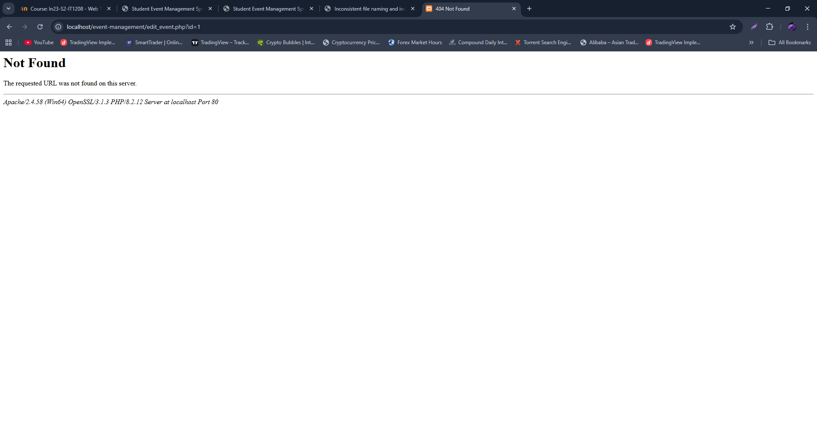

Challenge 2: Database Connection Issues
Issue: Initial attempts to connect before database creation failed
Solution: Created database setup script that creates database and tables on first run using CREATE DATABASE IF NOT EXISTS

Challenge 3: Session Management
Issue: Session variables were lost between page refreshes
Solution: Added session_start() at the beginning of config.php to ensure session is initialized on every request

Challenge 4: Date/Time Validation
Issue: Past dates were being accepted for event creation
Solution: Implemented both client-side (HTML min attribute) and server-side validation using strtotime() comparison

Challenge 5: Cascading Deletions
Issue: Deleting events left orphaned registration records
Solution: Added ON DELETE CASCADE constraint to foreign keys in database schema

🎯 Future Improvements
Email notifications for event registrations
QR code generation for event check-ins
Advanced search and filtering capabilities
Event category-based recommendations
Attendance tracking system
Export reports to PDF/Excel
Multi-language support Two-factor authentication

📚 Key Takeaways
Importance of proper planning and database design before coding
Security must be prioritized from the beginning, not added later
Consistent code structure and naming conventions improve maintainability
Testing and error handling are critical for production applications
User experience should drive technical decisions
Documentation and comments are essential for team collaboration

Conclusion

The Student Event Management System successfully demonstrates core web development principles and practices. The project integrates database design, backend logic, and frontend presentation into a cohesive application that solves a real-world problem. Through this project, significant progress was made in understanding full-stack development, security best practices, and professional software development workflows.
The system is fully functional and ready for deployment in an academic setting, providing valuable utility for campus event coordination and student engagement.
Generated: November 2025 | Student Event Management System v1.0

